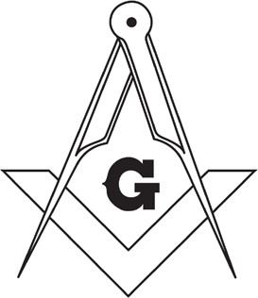
The host hotel is the Grant Hall, 401 Main St N, Moose Jaw. Room rates start at $160 and can be booked at
120th Annual Communication
GRAND LODGE OF SASKATCHEWAN
June 18th, 19th & 20th, 2026 – Moose Jaw, SK
1 (306) 691-2113. Use group code 609502. Deadline for the hotel block rate is May 17th, 2026.
Deadline to ensure your tickets for any of the events detailed below is June 5th, 2026.
Please complete the form in full, in print (no cursive).

Member Name:
Surname Given Name
REGISTRATION

Lodge Name: No. Jurisdiction:

Masonic Rank:
Circle: Bro. W Bro. VW Bro. RW Bro. MW Bro.
Masonic Title: Circle: JW SW WM PM

Mailing Address:
Street Address City Province Postal Code

Email Address: Guest’s Name:
(if applicable)

Phone:

Surname Given Name

Event Cost Quantity Total
EVENT TICKETS
Grand Master’s Meet & Greet - Thursday, June 18th: 7:00 pm to 10:00 pm  Grant Hall Hotel. Includes snacks (no meal). Cash bar.  Attire: Casual | $25
Grand Master’s Banquet - Friday, June 19th: 6:00 cocktails /6:30 supper  Grant Hall Banquet Room. Cash bar. Attire: Formal | $90
Men’s & Ladies’ Lunch - Saturday, June 20th: 12:00 noon  Grant Hall: Casual (Ladies), Business (Men) | $30
Incoming Grand Master’s Meet & Farewell - Saturday, June 20th:
5:00 pm - 8:00 pm
Bobbies Place. Attire: Casual - Al la Carte meal
Partners’ Program - Friday, June 19th: 1:00 pm - 4:00 pm  Western Development Museum Tour Attire: Casual Note: will conflict / overlap with the Ceremonial Opening. | $20
Partners’ Program - Saturday, June 20th: 9:00 am - 11:00 am  Trolly Tour of Moose Jaw Attire: Casual | $35
Dietary Restrictions: Grand Total

Online registration is available at https://tinyurl.com/GRSC2026 -- Send e-transfer to grsgrandcommunication2026@gmail.com
Or remit form and payment to: GLSask2026 c/o Nathan Reeves PO Box 219 Torquay, SK S0C 2L0.
Make cheques payable to 2026 Grand Lodge of Saskatchewan Communications

